Notice of Quorum
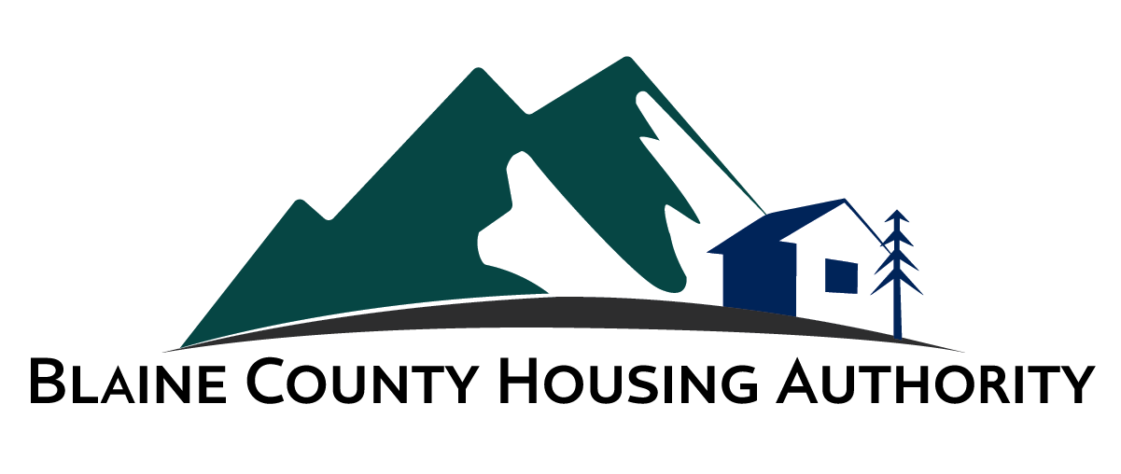

Notice that a of Quorum
of the
Board of Commissioners
of the
Blaine County Housing Authority
will be meeting via teleconference at the following times/days:

5:00 PM Wednesday, December 16, 2020

Each meeting will be held via Video Conferencing
To join from the web, please see below:
Web address: www.zoom.us/join
Meeting ID: 837 9109 6983
Password: 83333

To join by telephone, please dial the number below:
Phone Number: (669) 900-6833
Meeting ID: 837 9109 6983
Password: 83333

The meeting will be an informal discussion related to the activities of the Blaine County Housing Authority. No action items will be considered or approved by the Board at this meeting.

For more information, please contact the Blaine County Housing Authority at:

191 Sun Valley Road P.O. Box 4045 Ketchum, ID 83340
Phone: (208) 788-6102 Fax: (208) 788-6136 Email: info@bcoha.org

